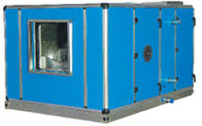

**AIR HANDLING UNIT**

HORZONTAL FLOOR MOUNTING UNITS

RANGE 1000CFM TO 40000CFM

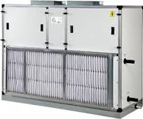

VERTICAL AIR HANDLING UNIT

RANGE 1200cfm to 18000cfm

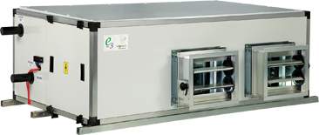

DUCTABLE CEILLING SUSPENDED UNITS

RANGE 1000CFM TO 12000CFM

(BELT DRIVEN, HI STATIC)

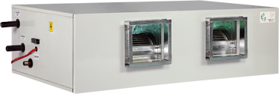

DUCTABLE CEILLING SUSPENDED UNITS

RANGE 1200CFM TO 5000CFM

(DIRECT DRIVEN, LOW STATIC)

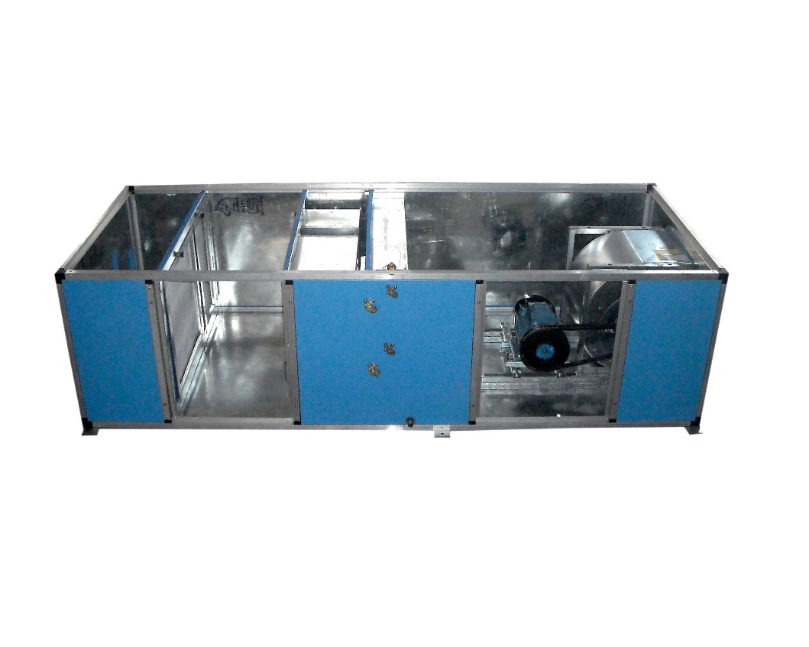

CLEAN ROOM AHU

Rang 1000cfm to 30000cfm

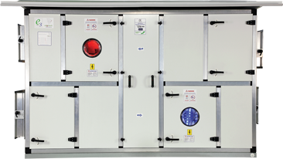

ENRGY RECOVERY UNIT

Rang 1200cfm to 30000cfm

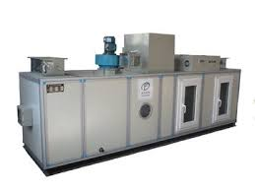

DEHUMIDEFIRE UNIT

Rang 1200cfm to 30000



TREATED FRESH AIR UNIT

RANG 1000cfm to 30000 cfm

(thermal break profile )